Name: Brihat Ratna Bajracharya
Roll No.: 19/075
Solution to Exercise 1 (Image Processing and Pattern Recognition)

Q1. Using vectorization and the colon operator, use a single command each to generate:
a. the first 15 cubes,
Solution
>> first_fifteen_cubes = [1:15] .^ 3

first_fifteen_cubes =

Columns 1 through 6

1 8 27 64 125 216

Columns 7 through 12

343 512 729 1000 1331 1728

Columns 13 through 15

2197 2744 3375

b. the values sin(nπ/16) for n from 1 to 16.
Solution
>> sine_function_ans = sin([1:16] .* pi / 16)

sine_function_ans =

Columns 1 through 8

0.1951 0.3827 0.5556 0.7071 0.8315 0.9239 0.9808 1.0000

Columns 9 through 16

0.9808 0.9239 0.8315 0.7071 0.5556 0.3827 0.1951 0.0000

Q2. Enter the following matrices:

Calculate
1. 2A – 3B 2. A^{T} 3. AB – BA
4. BC⁻¹ 5. (AB)^{T} 6. B^{T}A^{T}
7. A² + B³
Solution
>> A = [1 2 3; 2 3 4; 3 4 5]

A =

1 2 3
2 3 4
3 4 5

>> B = [-1 2 -1; -3 -4 5; 2 3 -4]

B =

-1 2 -1
-3 -4 5
2 3 -4

>> C = [0 -2 1; -3 5 2; 1 1 -7]

C =

0 -2 1
-3 5 2
1 1 -7

>> calc_21_ans = 2 * A - 3 * B

calc_21_ans =

5 -2 9
13 18 -7
0 -1 22

>> calc_22_ans = A'

calc_22_ans =

1 2 3
2 3 4
3 4 5

>> calc_23_ans = A * B - B * A

calc_23_ans =

-1 3 -3
-7 2 -3
-1 8 -1

>> calc_24_ans = B * C^(-1)

calc_24_ans =

0.2333 0.4333 0.3000
4.9000 1.1000 0.3000
-3.3000 -0.7000 -0.1000

>> calc_25_ans = (A * B)'

calc_25_ans =

-1 -3 -5
3 4 5
-3 -3 -3

>> calc_26_ans = B' * A'

calc_26_ans =

-1 -3 -5
3 4 5
-3 -3 -3

>> calc_27_ans = A^2 + B^3

calc_27_ans =

90 103 -92
-154 -132 286
163 167 -147

Q3. Type following commands in MATLAB and see what it gives
>> w = imread('tire.tif');
>> figure, imshow(w), impixelinfo
Solution
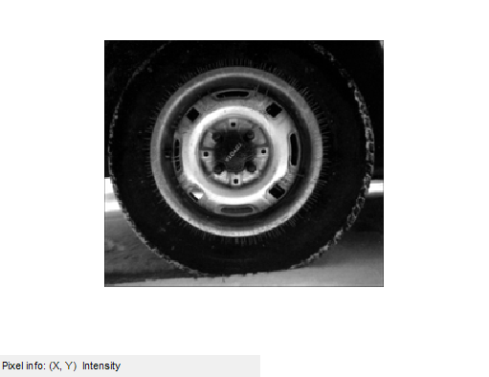

RGB Image
>> a = imread('autumn.tif');
>> figure, imshow(a), impixelinfo
>> size(a)
Solution
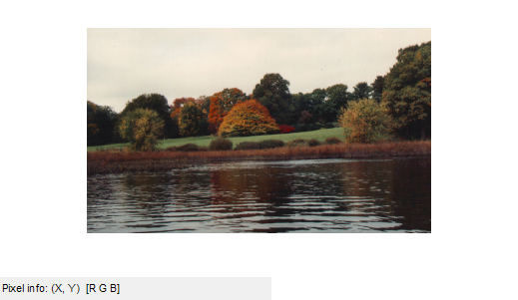
ans =

206 345 3

Information about your image
>> imfinfo('autumn.tif')
Solution
ans =

Filename: 'D:\MATLAB\MATLAB Production Server\R2015a\too...'
FileModDate: '04-Dec-2000 08:12:54'
FileSize: 213642
Format: 'tif'
FormatVersion: []
Width: 345
Height: 206
BitDepth: 24
ColorType: 'truecolor'
FormatSignature: [73 73 42 0]
ByteOrder: 'little-endian'
NewSubFileType: 0
BitsPerSample: [8 8 8]
Compression: 'Uncompressed'
PhotometricInterpretation: 'RGB'
StripOffsets: [1x30 double]
SamplesPerPixel: 3
RowsPerStrip: 7
StripByteCounts: [1x30 double]
XResolution: 72
YResolution: 72
ResolutionUnit: 'Inch'
Colormap: []
PlanarConfiguration: 'Chunky'
TileWidth: []
TileLength: []
TileOffsets: []
TileByteCounts: []
Orientation: 1
FillOrder: 1
GrayResponseUnit: 0.0100
MaxSampleValue: [255 255 255]
MinSampleValue: [0 0 0]
Thresholding: 1
Offset: 213218

Q4. Pick a grayscale image, say cameraman.tif or wombats.tif. Using the imwrite function,
Write it to files of type JPEG, PNG and BMP.
What are the sizes of those files?
Solution
>> cameraman = imread('cameraman.tif');
>> imwrite(cameraman,'cameramanpng.png','png');
>> imwrite(cameraman,'cameramanbmp.jpg','jpg');
>> imwrite(cameraman,'cameramanbmp.bmp','bmp');

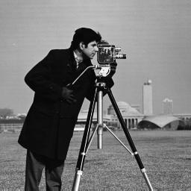Figure 1: cameraman (JPG)
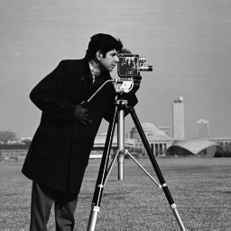Figure 2: cameraman (PNG)
Figure 3: cameraman (BMP)

Size of cameraman (JPG) is 10.4 KB.
Size of cameraman (PNG) is 37.3 KB.
Size of cameraman (BMP) is 65.0 KB.

